Name: BOYA DRAVEEN KUMAR

Trainer Name:HARSHEE PITRODA

Batch Number: **09(G-15)**

Course Name:**Mechain learning with python**

Date:**04-Jun-2022**

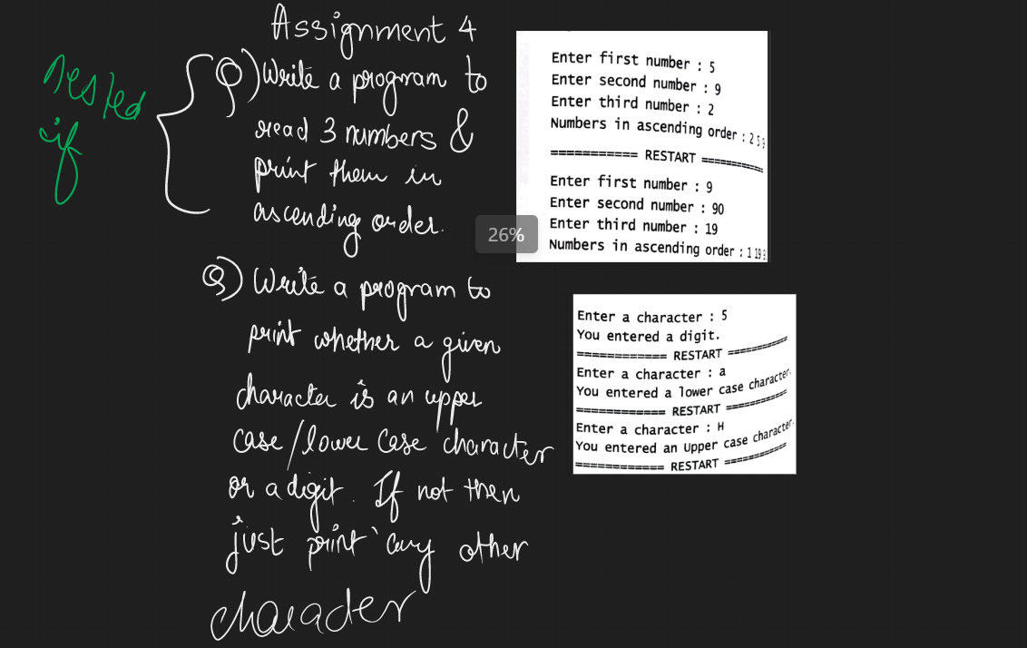

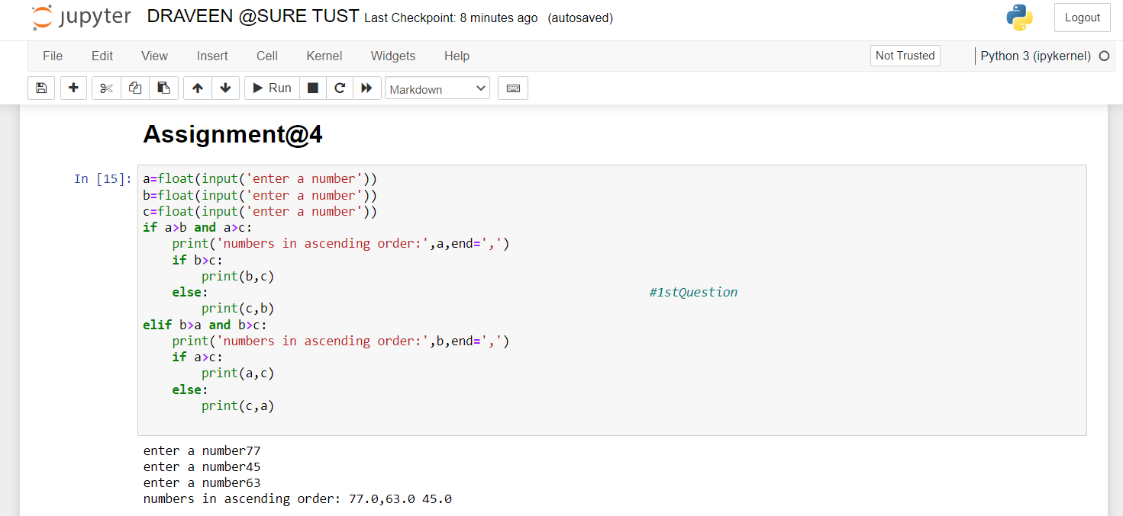

a=float(input('enter a number'))

b=float(input('enter a number')) #1St Question

c=float(input('enter a number'))

if a>b and a>c:

print('numbers in ascending order:',a,end=',')

if b>c:

print(b,c)

else:

print(c,b)

elif b>a and b>c:

print('numbers in ascending order:',b,end=',')

if a>c:

print(a,c)

else:

print(c,a)

Sample input:

enter a number77

enter a number45

enter a number63

Sample output:

numbers in ascending order: 77.0,63.0 45.0



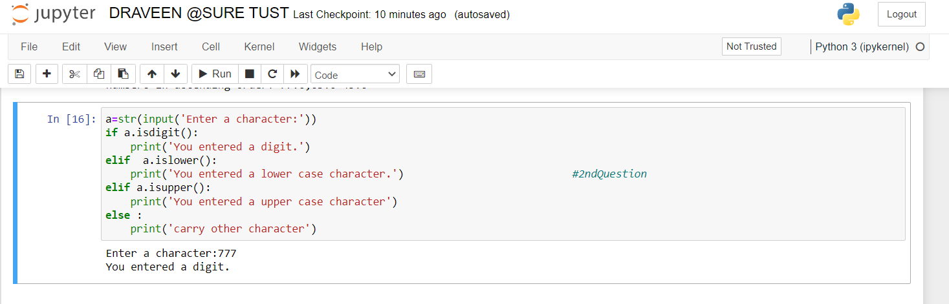

a=str(input('Enter a character:'))

if a.isdigit():

print('You entered a digit.')

elif a.islower():

print('You entered a lower case character.') #2nd Question

elif a.isupper():

print('You entered a upper case character')

else :

print('carry other character')

Sample input:

Enter a character:777

Sample output:

You entered a digit.